William Fan

Assignment 1

Prof. Chiang

NWIT 105

Using NotebookLM was mostly a smooth and expedient experience. It has a nice human-centered design, and the operational language makes it largely instruction-free. I was able to upload multiple types of resources such as PDFs, TXT, and Markdown files. However, it was surprisingly not able to take Pages files or DOCX files. After a brief transition of file types, I was able to upload everything smoothly. NotebookLM will basically take all the scraps of information you provide and generate content from them. The study guide took a little over a minute to generate, which was quite impressive since I uploaded 20 files. However, the content was a little too generic. It has a preset sectioning method since it weights different types of content evenly. For example, I had 18 files of practice questions, one syllabus, and one homework assignment, but the generated guide had four equal parts with similar word counts. I wish I had more control over this so I could emphasize certain parts. I might use it again and actually incorporate it into my certification preparation.

Fact 1:

It tried to eliminate hallucinations during conversation by including citations, but it only applies to chat mode (Learn Prompting).

Fact 2:

Further customization and setting styles are only available in the un-free option of the software (Gulati, Paragraph 5).

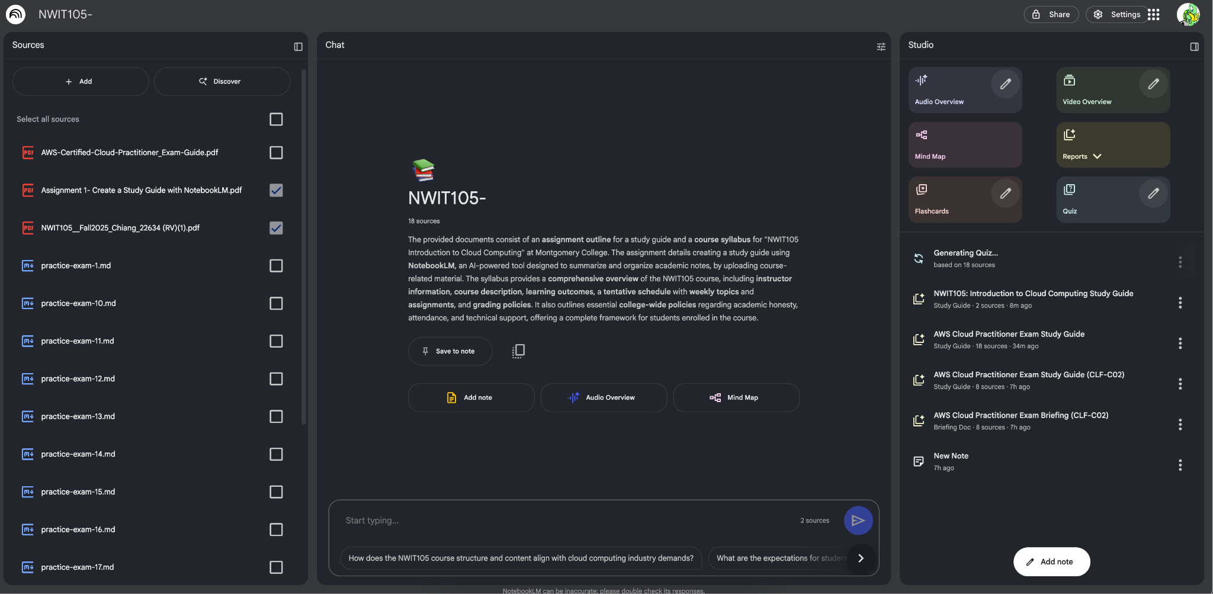

Work Cited:  
1. Gulati, Jayita. “The Ultimate Guide to Learning Anything with NotebookLM.” KDnuggets, 19 May 2025, www.kdnuggets.com/the-ultimate-guide-to-learning-anything-with-notebooklm.

2. Kilpatrick, Chandler. “A Complete How-To Guide to NotebookLM.” Learn Prompting, 8 Jan. 2025, learnprompting.org/blog/notebooklm-guide.